**PROYECTO FINAL RETO 1**

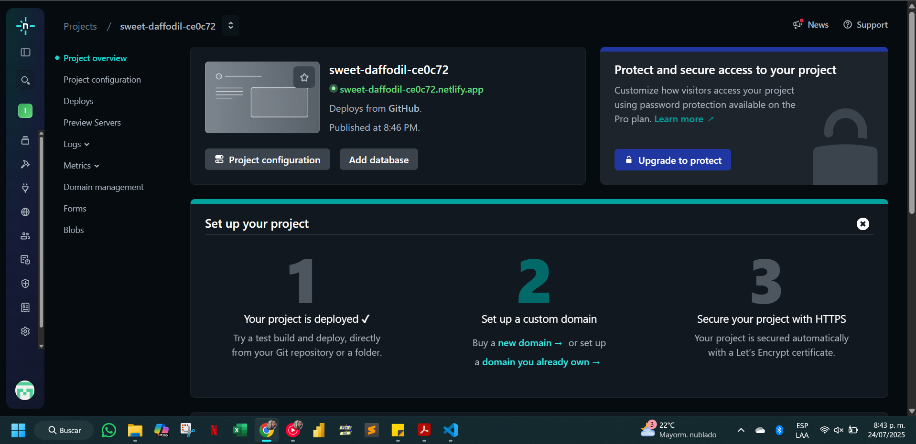

[**sweet-daffodil-ce0c72.netlify.app**](https://sweet-daffodil-ce0c72.netlify.app/)